**Name:M.K.Vishnupriyan**

**Reg-No:73772121222**

**Dept: Information Technology**

1. CREATING CLIENT_MASTER TABLE

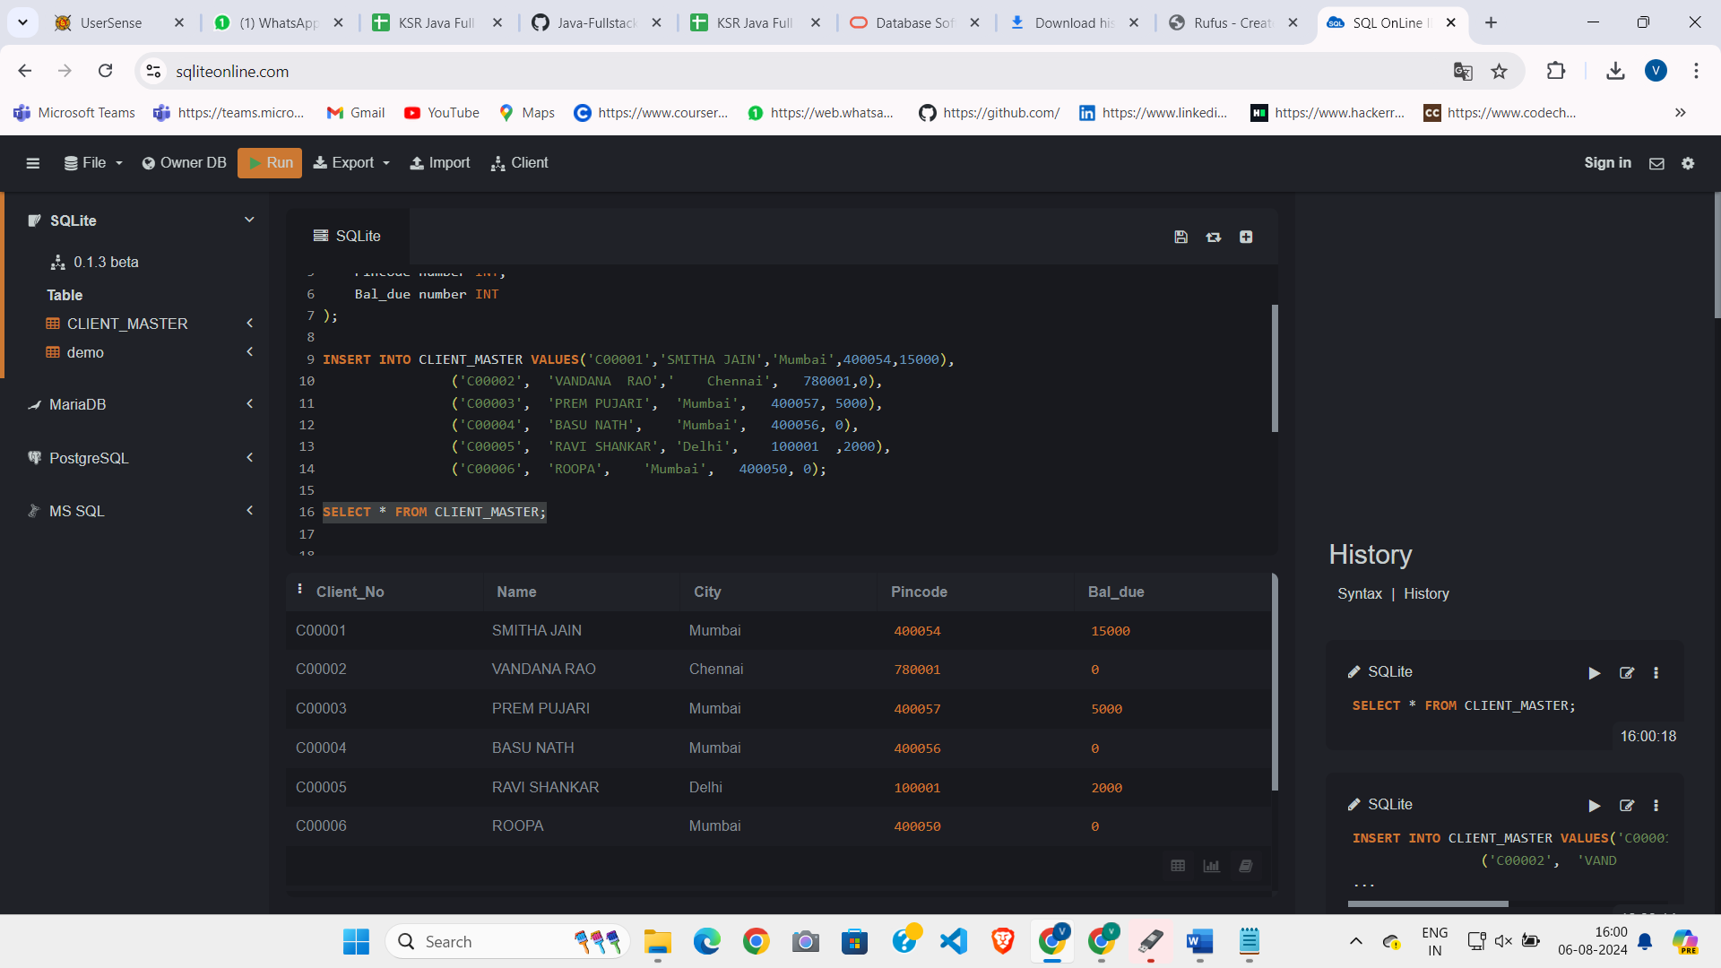

1. CREATING SALE_ORDER

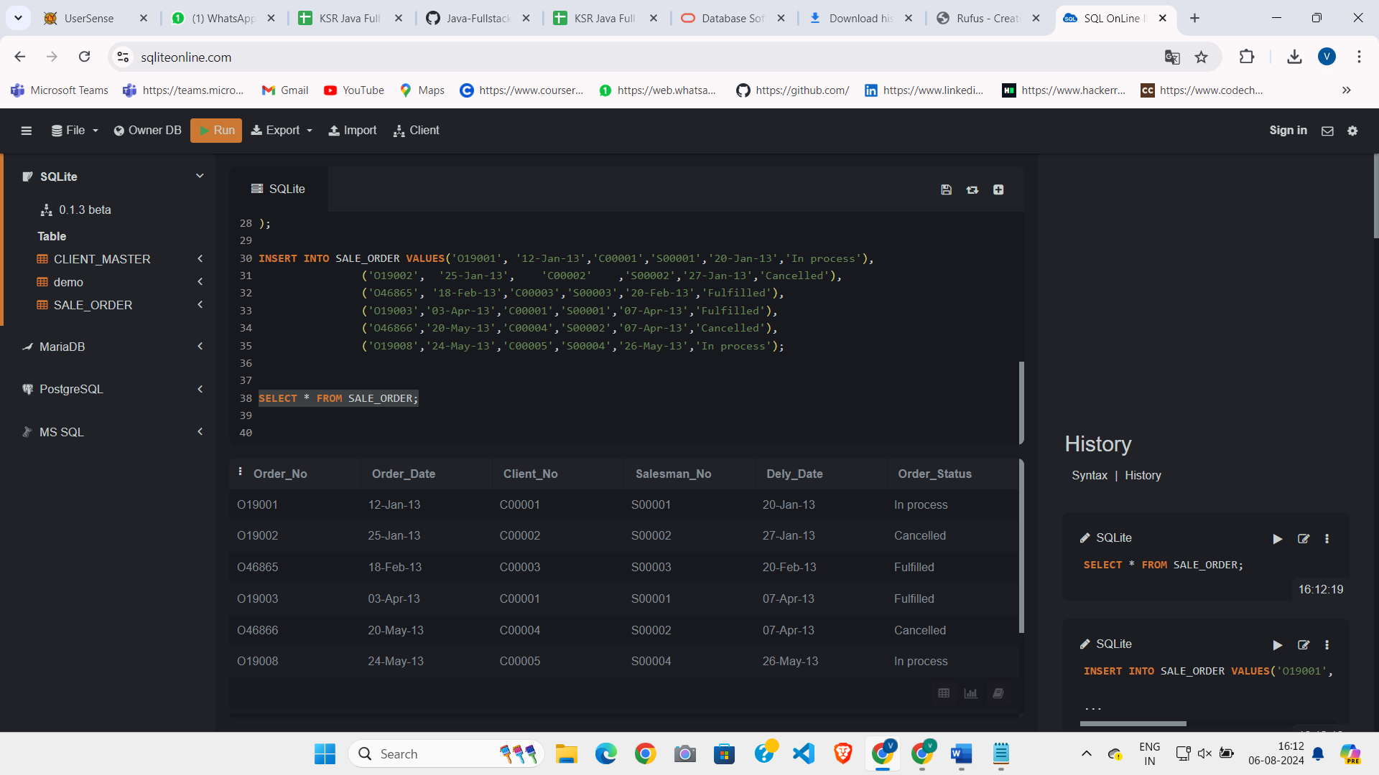

1. List details from client_master where bal_due=0

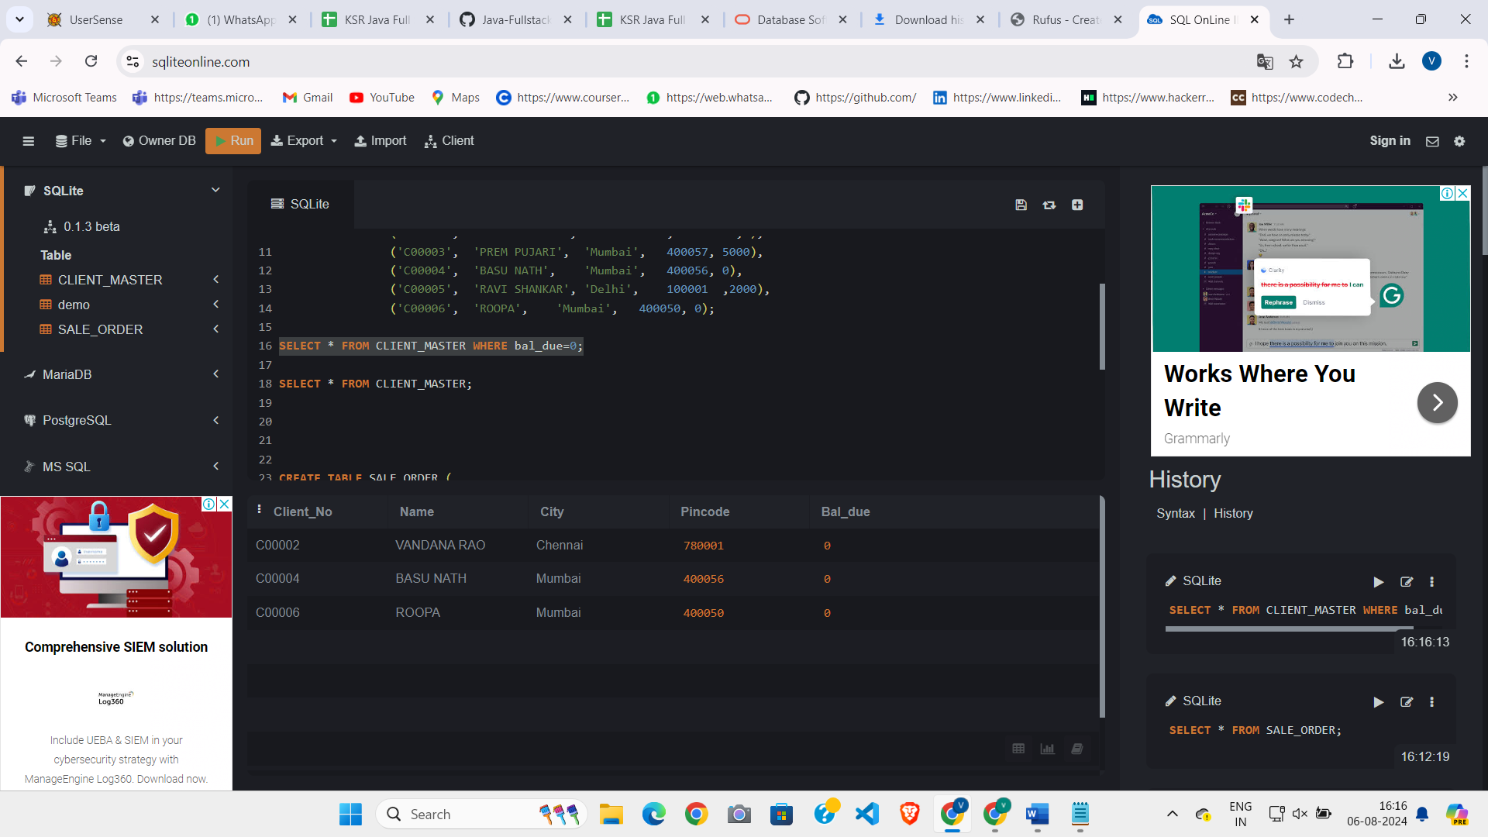

1. Update client_master by change city of client_no C00004 to Jaipur

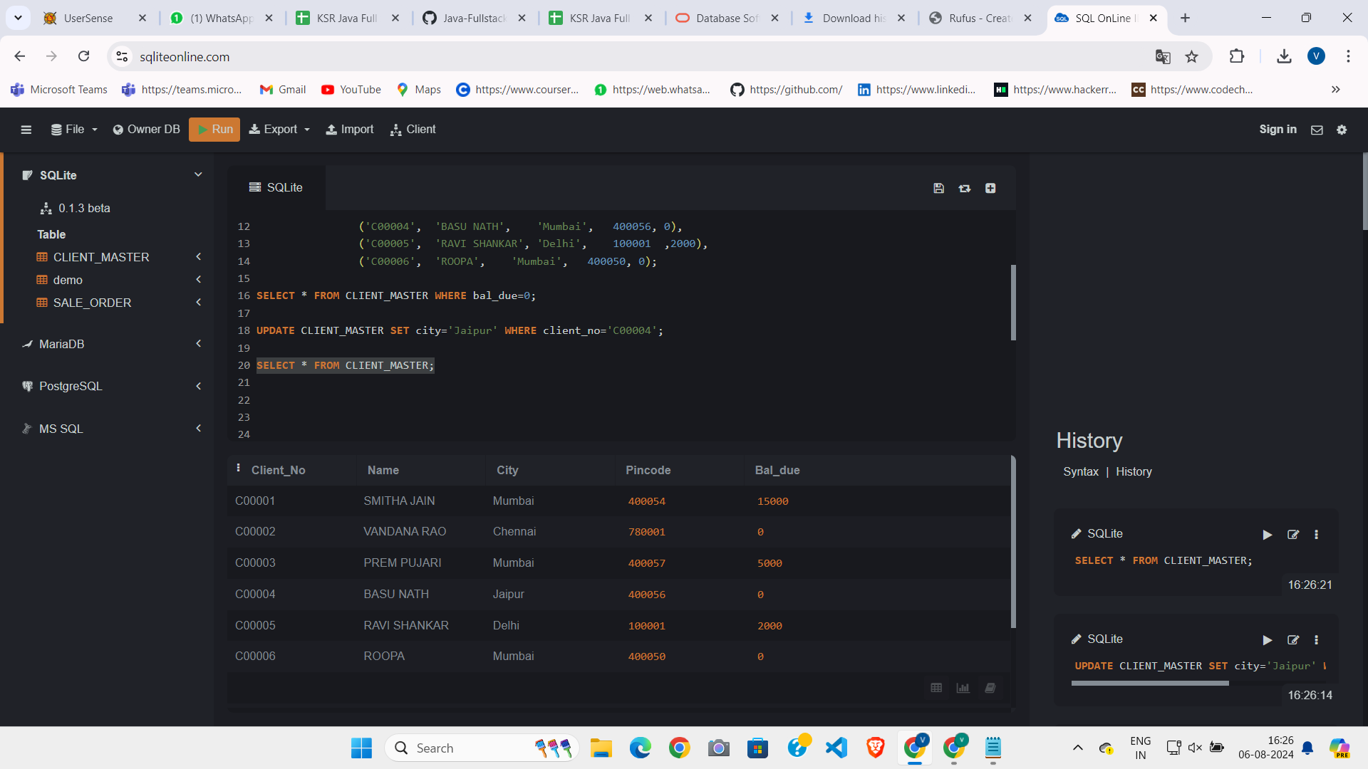

1. Retrive records of clients residing in Mumbai

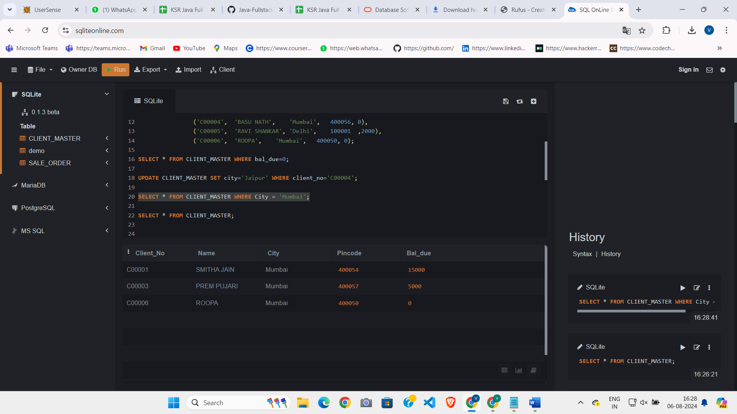

1. Name and Address of the customer order_no ‘O19003’ and ‘O19002’

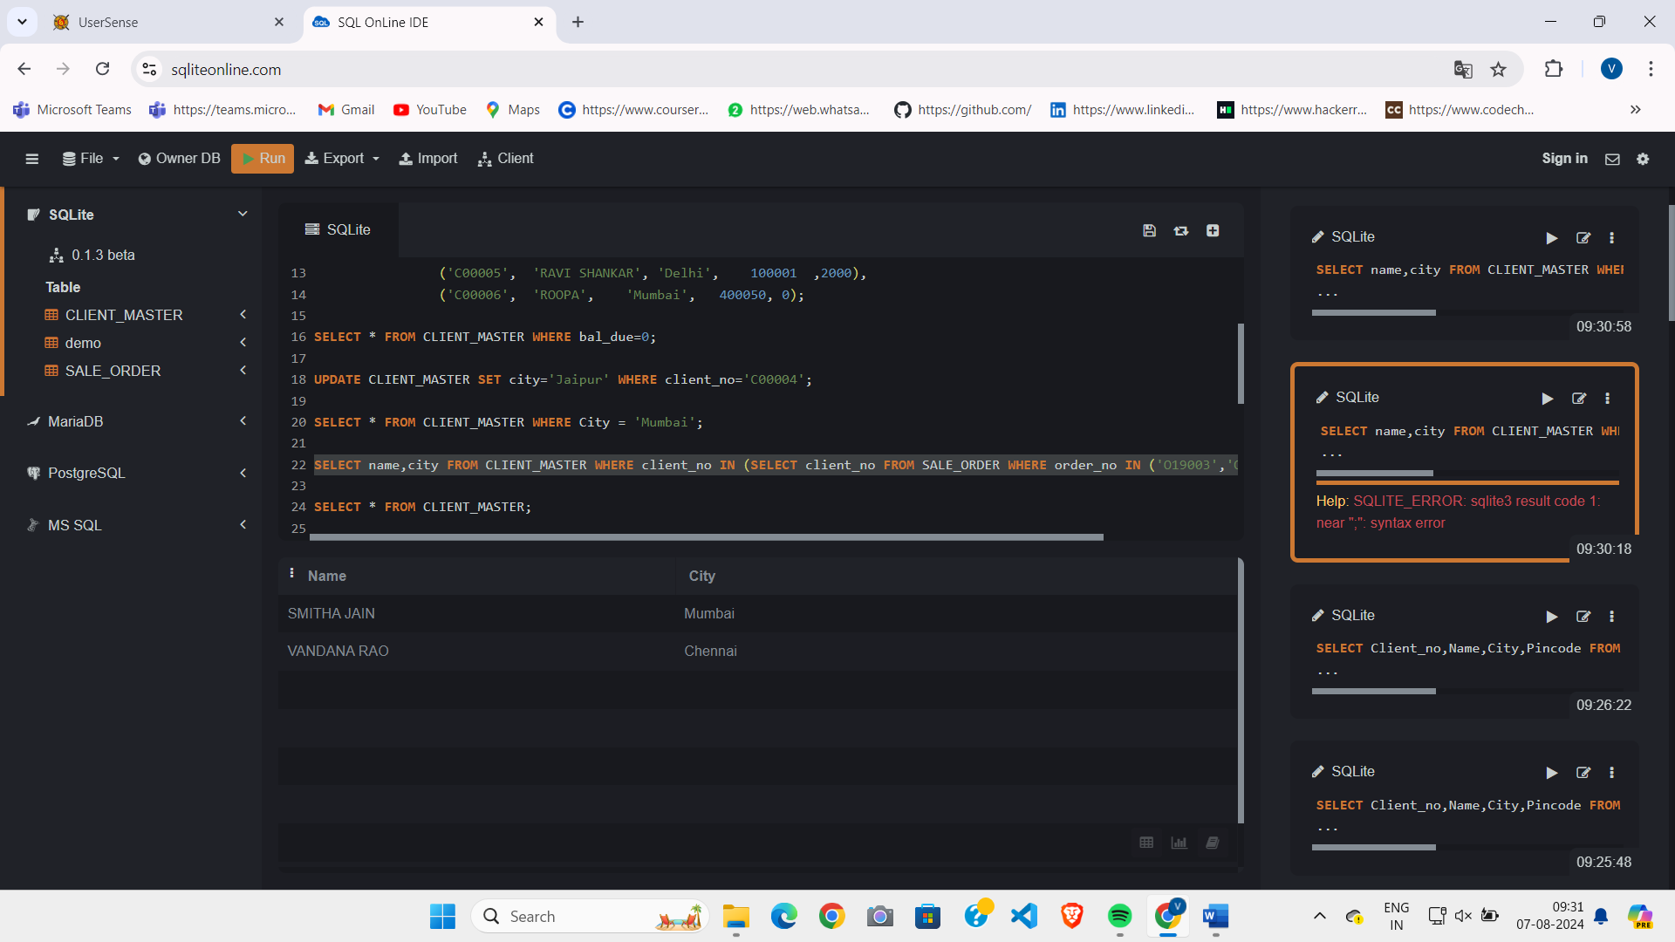

1. Construct English liske dentence from table client_master
2. List the client_no, name, city and pincode of clients whose order is “in progress”

